Diabetic Retinopathy Detection System

1. INTRODUCTION

1.1 Project Overview
Diabetic Retinopathy (DR) is a diabetes-related eye disease that can lead to vision loss or blindness if not detected early. Manual screening requires expert ophthalmologists and is time-consuming.
This project presents an AI-powered web application that uses Deep Learning and Transfer Learning (Xception Model) to automatically classify retinal fundus images into different stages of Diabetic Retinopathy.
The system provides an accessible, fast, and automated prediction mechanism through a Flask-based interface.

1.2 Purpose
The purpose of this project is:
- To develop an AI-based automated detection system for diabetic retinopathy.
- To reduce manual workload for ophthalmologists.
- To detect DR at early stages before symptoms become severe.
- To improve accessibility of retinal screening in rural and remote areas.
- To minimize diagnostic errors using deep learning techniques.

2. IDEATION PHASE

2.1 Problem Statement
- Diabetic Retinopathy is a leading cause of blindness among diabetic patients.
- Early detection is essential to prevent permanent vision loss.
- Manual diagnosis requires expert ophthalmologists and is time-consuming.
- Screening is costly and not easily available in rural areas.
- An AI-based automated system is needed for fast, accurate, and affordable detection.

2.2 Empathy Map Canvas
Users: Diabetic patients, Ophthalmologists, Hospital screening staff.

Think | Feel | Say | Does
Fear of blindness | Anxiety about vision | Want early detection | Visit early detection
Trust in AI | Hope for recovery | Need accurate results | Undergo retinal scan

2.3 Brainstorming
Ideas generated:
- Use CNN and transfer learning models for image classification.
- Perform image preprocessing and data augmentation.
- Classify DR into multiple severity stages.
- Develop a simple image upload interface with result display.
- Add report generation and heatmap visualization for explainability.

3. REQUIREMENT ANALYSIS

3.1 Customer Journey Map
- Patient experiences vision problems.
- Patient visits hospital or eye clinic.
- Retinal image is captured using a fundus camera.
- Image is uploaded to the detection system.
- AI system analyzes and predicts DR stage.
- Doctor reviews results and provides treatment advice.

3.2 Solution Requirement

Functional Requirements
- Upload retinal images.
- Preprocess and enhance image quality.
- Classify DR severity levels.
- Display results with confidence score.
- Generate and store reports.

Non-Functional Requirements
- High accuracy and fast processing.
- Secure patient data handling.
- User-friendly interface.
- Scalable for hospitals.
- Reliable system performance.

3.3 Data Flow Diagram (DFD)
Level 0 DFD
Patient ----> (Diabetic Retinopathy Detection System) ----> Doctor/Admin
| |
|<------------------- Treatment Advice -----------------------------|

3.4 Technology Stack
Layer | Technology Used
Presentation Layer | HTML, CSS, Flask
Application Layer | Flask (Python)
AI Model Layer | TensorFlow / Keras ,Xception
Image Processing Layer | Pillow , NumPy
Data Layer | IBM cloudant

4. PROJECT DESIGN

4.1 Problem Solution Fit
Problem: Manual detection of Diabetic Retinopathy is time-consuming, costly, and requires expert ophthalmologists, leading to delayed diagnosis.
Solution: An AI-based deep learning system automatically analyzes retinal images and provides fast, accurate DR stage prediction through a web application.

4.2 Proposed Solution
We developed a Deep Learning based classification system that:
- Analyzes retinal fundus images.
- Uses Transfer Learning(Xception) for feature extraction.
- Predicts DR severity stages.
- Provides results through a web interface.
- Logs predictions using IBM Cloudant Database.

4.3 Solution Architecture
User Layer
↓
Flask Web Application Layer .
↓
Image Processing Layer .
↓
AI Model Layer (Xception - Transfer Learnig) .
↓
Database Layer (IBM Cloudant) .
↓
Result Display

5. PROJECT PLANNING & SCHEDULING

5.1 Project Planning
Phase | Duration
Problem Identification | 2 Days
Dataset Collection | 4 Days
Model Training | 7 Days
Web Development | 4 Days
Testing & Deployment | 3 Days
Total Duration: 20 Days

6.FUNCTIONAL AND PERFORMANCE TESTING

6.1 Performance Testing
- Measures the time taken by the system to generate prediction results.
- Evaluates the accuracy of the Xception model on test data.
- Checks the response time of the Flask web application.
- Tests system stability under multiple user requests.
- Ensures reliable and consistent performance without crashes.

7.RESULTS
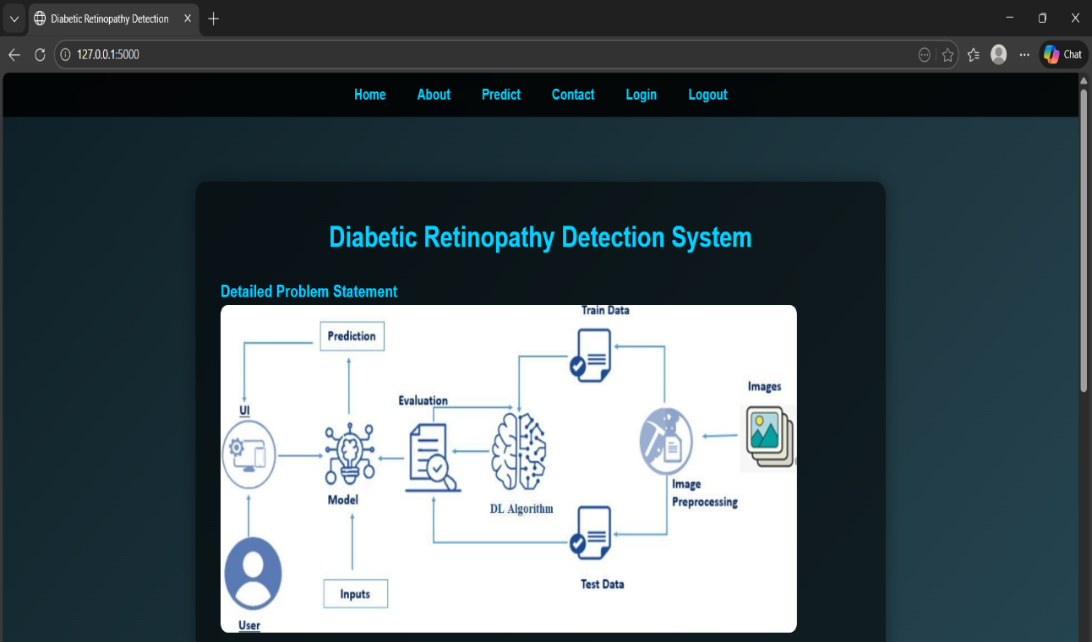
e
Step-1: Problem Identification
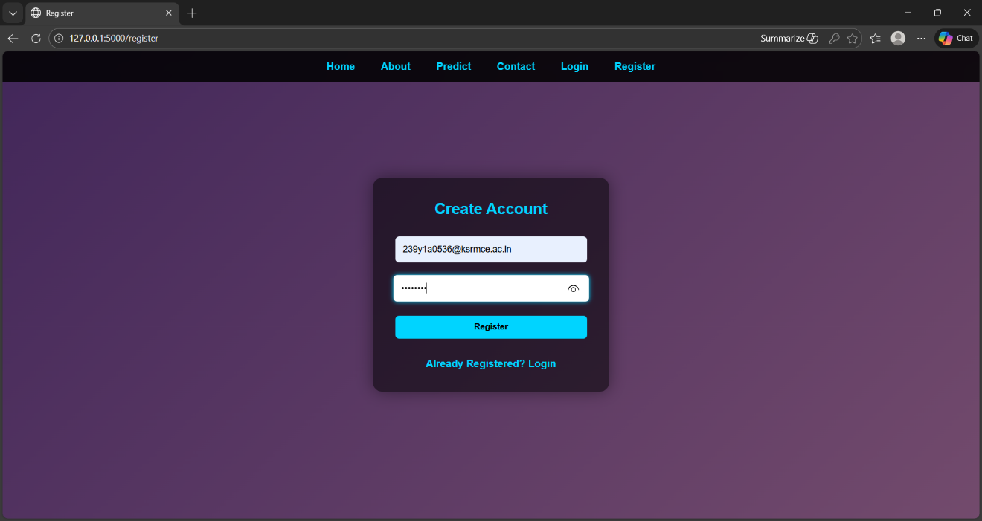
Step-2: Dataset Collection (Retinal Fundus Images)

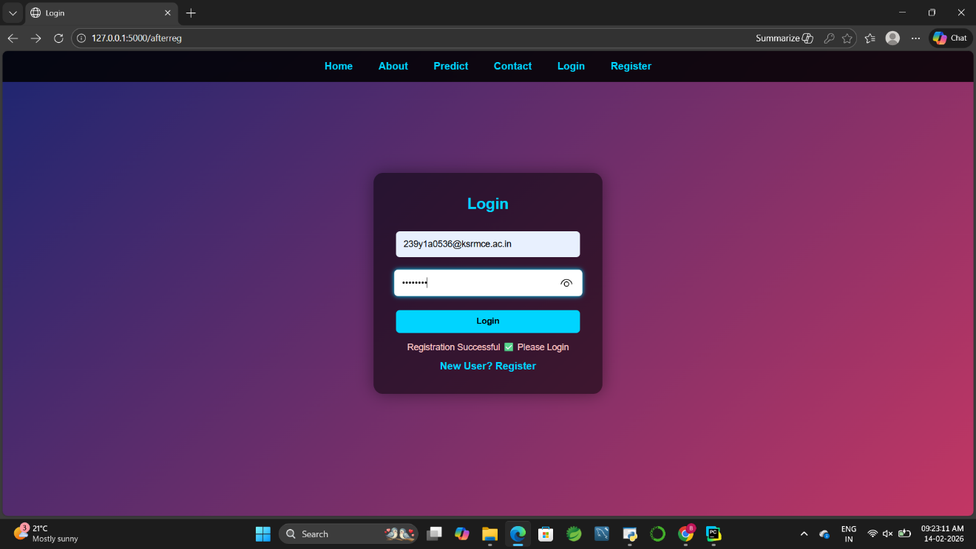

Step-3: Image Preprocessing

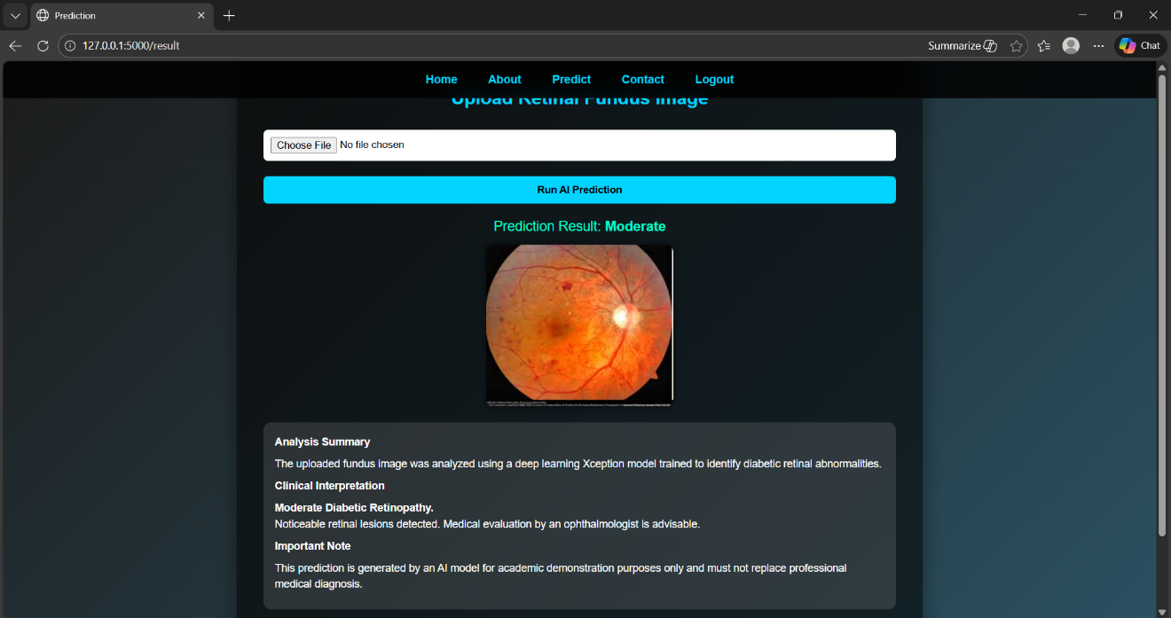
Step-4: Data Splitting (Train & Test Data)
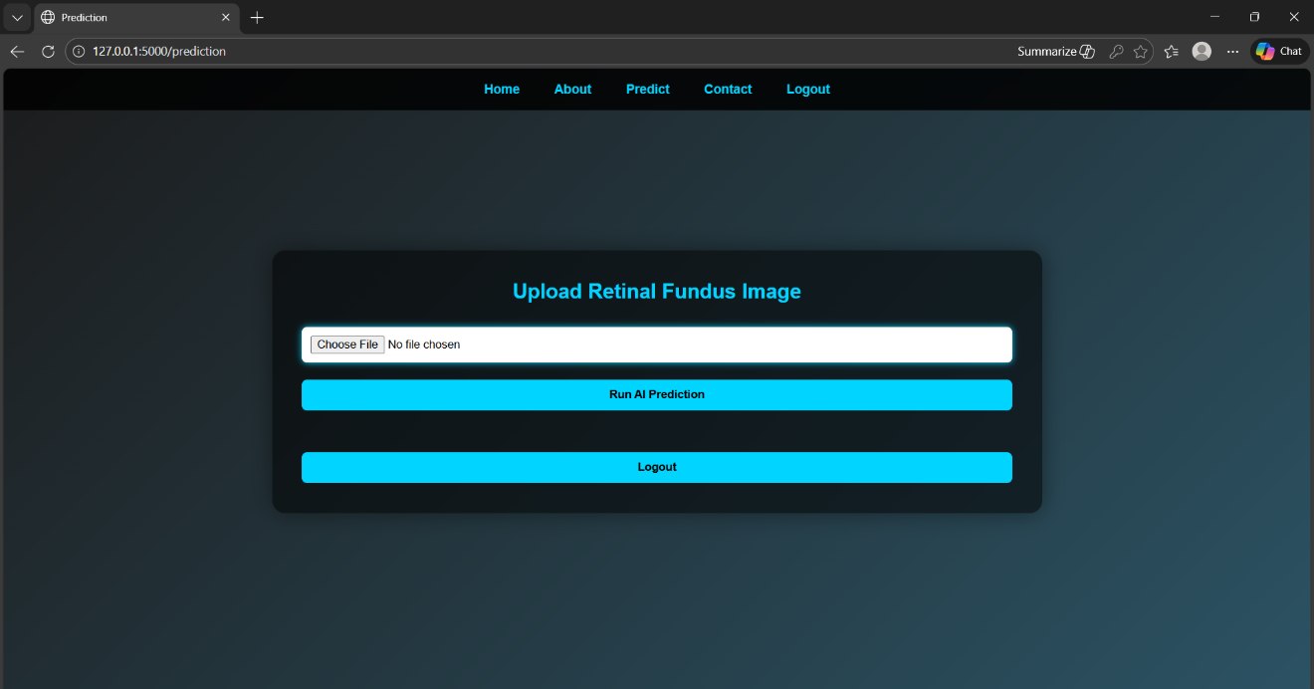

Step-5: Model Development (Xception – Transfer Learning)

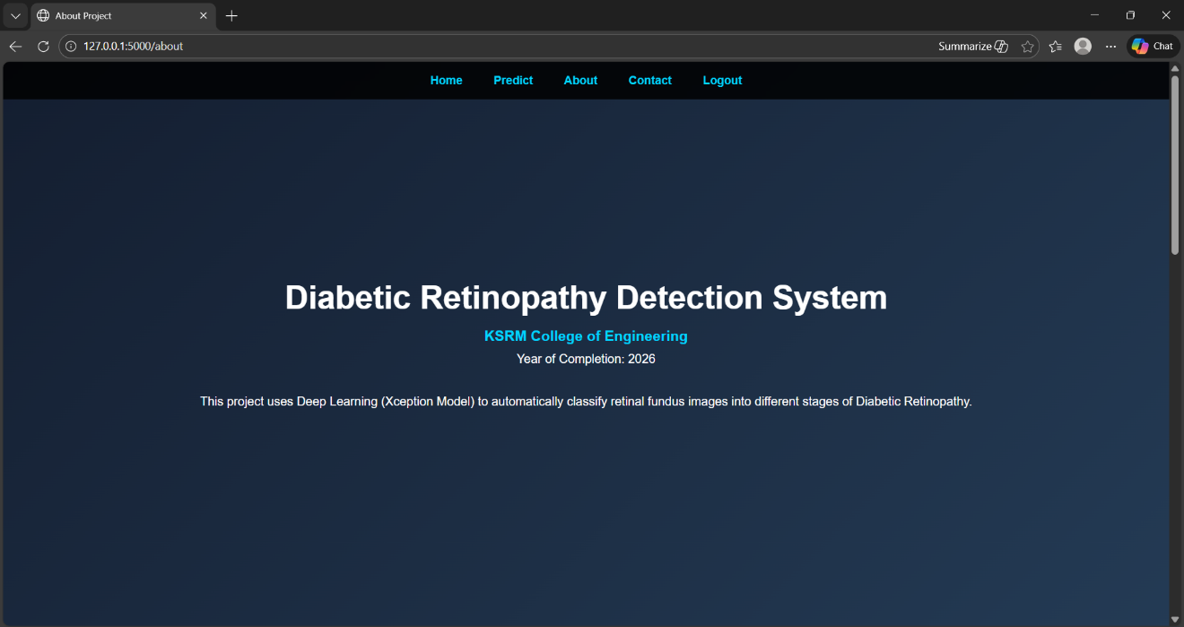
Step-6: Model Training

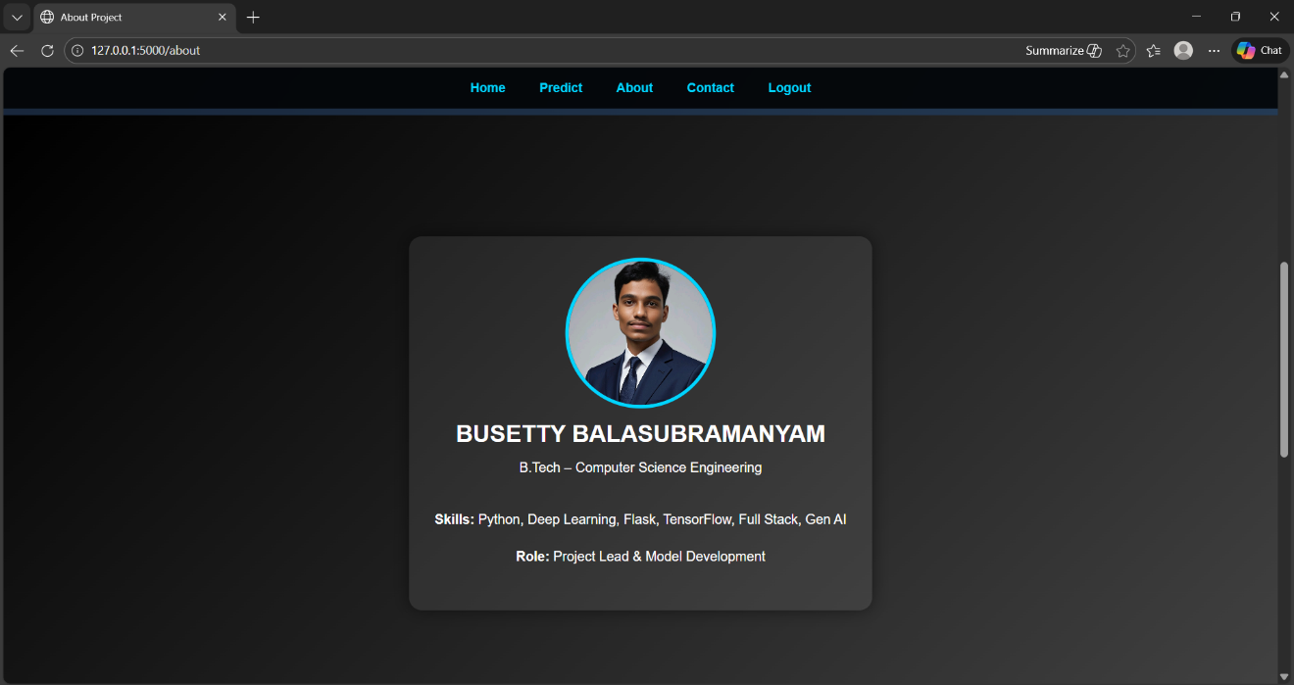

Step-7: Model Evaluation & Validation

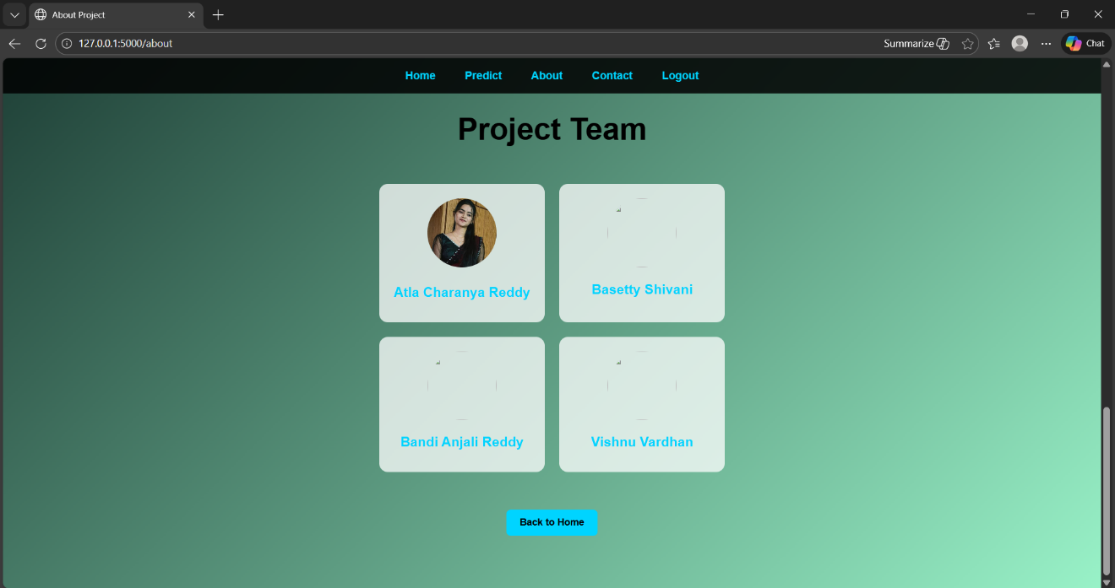
Step-8: Web Application Integration (Flask UI)

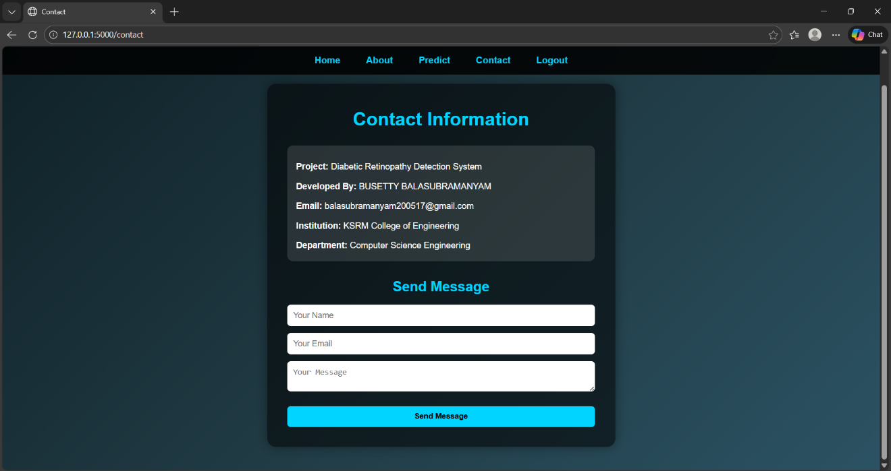

Step-9: Prediction & Result Display to User

8. ADVANTAGES & DISADVANTAGES

Advantages
- Early disease detection
- Reduced expert dependency
- Fast automated diagnosis
- Cost effective screening
- Web based access

Disadvantages:
- Dataset quality dependent
- Requires internet connection
- Not doctor replacement
- Possible misclassification risk
- Regular model maintenance

9. CONCLUSION
The Diabetic Retinopathy Detection System successfully demonstrates the use of Deep Learning for early detection of retinal diseases. By utilizing the Xception transfer learning model, the system accurately classifies fundus images into different DR stages. The Flask-based web application provides a fast, user-friendly, and automated screening solution. This project reduces dependency on manual diagnosis and supports doctors in decision-making. Overall, the system contributes to early diagnosis, improved healthcare efficiency, and prevention of vision loss.

10. FUTURE SCOPE
- Develop a mobile application for easier access.
- Improve model accuracy using larger datasets.
- Integrate real-time retinal scan devices.
- Deploy system on cloud for large-scale screening.
- Add explainable AI features for better transparency.

11. APPENDIX

Source Code
(Include your Python files like:)
- app.py
- model_utils.py
- templates/index.html
- requirements.txt

Dataset Link
Source: Kaggle
Dataset: Diabetic Retinopathy Level Detection
Preprocessing: Image resizing, normalization, augumentation.
Example:
Kaggle, “Diabetic Retinopathy Detection Dataset,” Available: https://www.kaggle.com

